Open this picture and analyze it as if you were a latent print examiner. You will see an impression with ridge events and features marked. You should:
- Identify the pattern.
- Determine what the indicated ridge events/features are, including the pattern type (there are a total of 20 items to classify). Simply make a list (1–20) and write down your labels, i.e., type of pattern, bifurcation, creases, dot, ending ridge, pore etc. DO NOT provide an explanation of these items.
Part 2
Explain in a 1–2-page essay the properties of skin and the relationship to friction-skin impressions. Consider such items as elasticity, scarring, distortion, the condition of the skin etc.
Note: Part 2 is an Essay that is independent of Part 1.
Here is the fingerprint
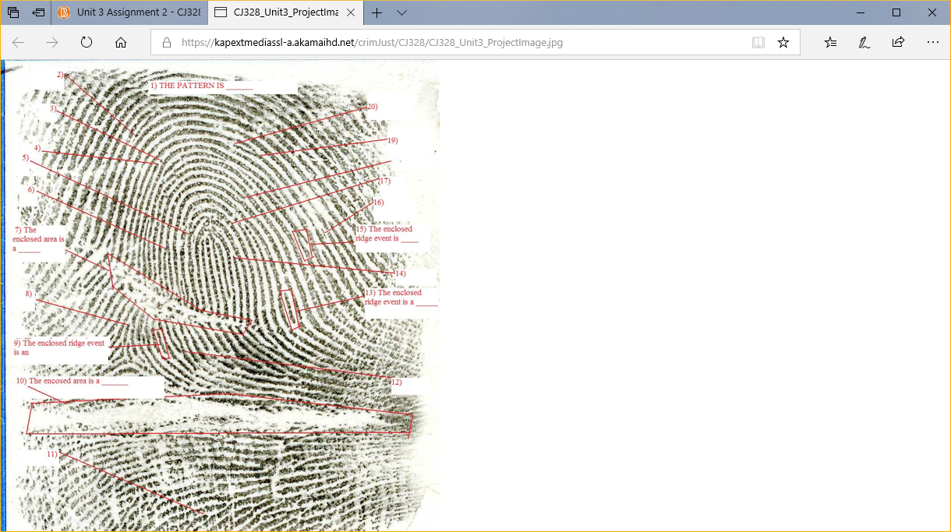

Ridge Events
What are ridge events? How are ridge events in a unit formation used to determine identification or non-identification? How does the concept of ridge events in a unit formation differ from pattern types in fingerprint identification?

Daubert Hearings
Discuss the effect the Daubert Hearings have had on the fingerprint community. Include in your response the effect the Daubert Hearings have had on the fingerprint community, scientific evidence, and the expert witness.

